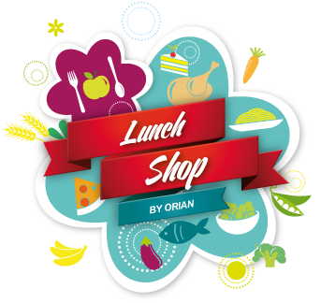
Freshly made every day!
castle park School
Week 1

Day | Choice 1 | Choice 2 |  |  | PUDDING
Monday | Cheese & Tomato Pizza  served with Potato Smiles and Salad | Oven Baked Jacket Potato  with a choice of Cheese, Tuna, Baked Beans and Cheesy Beans served with salad |  | Chocolate Crunch  or  Fresh Fruit or Frozen Yoghurt
Tuesday | Pork Sausages  served with Mash Potato, Peas and Gravy | Oven Baked Jacket Potato  with a choice of Cheese, Tuna, Baked Beans and Cheesy Beans served with salad |  | Iced Carrot Cake  or  Fresh Fruit or Frozen Yoghurt
 | Chicken Korma  (including Carrot & Sweetcorn)  served with Rice | Oven Baked Jacket Potato  with a choice of Cheese, Tuna, Baked Beans and Cheesy Beans served with salad |  | Raspberry Bun  or  Fresh Fruit or Frozen Yoghurt
Thursday | Beef Bolognaise  served with Pasta and Garlic Bread | Oven Baked Jacket Potato  with a choice of Cheese, Tuna, Baked Beans and Cheesy Beans served with salad |  | Chocolate Muffin  or  Fresh Fruit or Frozen Yoghurt
Friday | Salmon Fingers  served with Chips, Baked Beans and Tomato Ketchup | Oven Baked Jacket Potato  with a choice of Cheese, Tuna, Baked Beans and Cheesy Beans served with salad |  | Oaty Cookie  or  Fresh Fruit or Frozen Yoghurt
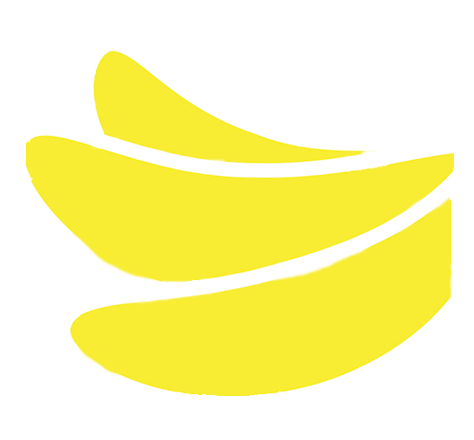
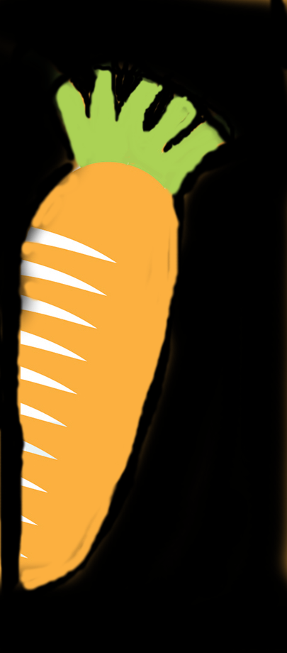
Available Daily: Fresh Fruit and Bread!
Wednesday
If you have any questions about food allergens please speak to the kitchen team who will be happy to help.
ORFORM43 ISSUE 1 – 18.10.18 SPRING 2021
Freshly made every day!
castle park School
Week 2

Day | Choice 1 | Choice 2 |  |  | PUDDING
Monday | Cheese & Tomato Pizza  served with Chips and Sweetcorn | Oven Baked Jacket Potato  with a choice of Cheese, Tuna, Baked Beans and Cheesy Beans served with salad |  | Shortbread  or  Fresh Fruit or Frozen Yoghurt
Tuesday | Cottage Pie  served with Mixed Vegetables | Oven Baked Jacket Potato  with a choice of Cheese, Tuna, Baked Beans and Cheesy Beans served with salad |  | Flapjack  or  Fresh Fruit or Frozen Yoghurt
 | Pork Meatballs in Gravy  served with Pasta and Peas | Oven Baked Jacket Potato  with a choice of Cheese, Tuna, Baked Beans and Cheesy Beans served with salad |  | Chocolate Brownie  or  Fresh Fruit or Frozen Yoghurt
Thursday | Roast Chicken Fillet  served with Creamed Potatoes, Broccoli, Carrots and Gravy | Oven Baked Jacket Potato  with a choice of Cheese, Tuna, Baked Beans and Cheesy Beans served with salad |  | Iced Lemon Cake  or  Fresh Fruit or Frozen Yoghurt
Friday | Breaded Fish Fingers  served with Potato Wedges, Baked Beans and Tomato Ketchup | Oven Baked Jacket Potato  with a choice of Cheese, Tuna, Baked Beans and Cheesy Beans served with salad |  | Vanilla Muffin  or  Fresh Fruit or Frozen Yoghurt
Available Daily: Fresh Fruit and Bread!
Wednesday
If you have any questions about food allergens please speak to the kitchen team who will be happy to help.
ORFORM43 ISSUE 1 – 18.10.18 SPRING 2021

