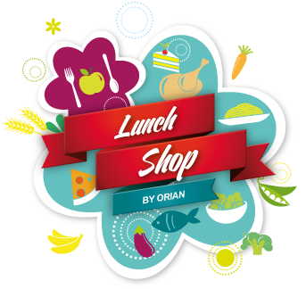
Freshly made every day!
selside school
Week 1

Day | Choice 1 |  | Choice 2 | Choice 3 |  | PUDDING
Monday | Margherita Pizza  served with Baked Beans, Carrot and Cucumber Sticks |  | Oven Baked Jacket Potato  filled with Cheese, Tuna, Beans and Cheese & Beans served with Carrot & Cucumber Sticks |  | Assorted Sandwiches  filled with Ham, Cheese or Tuna served with Carrot & Cucumber Sticks |  | Custard Cookie  or  Fruit Salad and Yoghurt
Tuesday | Chicken Karahi Curry  served with Rice, Peas and Naan Bread |  | Oven Baked Jacket Potato  filled with Cheese, Tuna, Beans and Cheese & Beans served with Mixed Salad |  | Assorted Sandwiches  filled with Ham, Cheese or Tuna served with Mixed Salad |  | Chocolate Brownie  or  Fruit Salad & Yoghurt
 | Roast Chicken Breast  served with Creamed Potato, Green Bean & Carrot Medley and Gravy | Oven Baked Jacket Potato  filled with Cheese, Tuna, Beans and Cheese & Beans served with Mixed Salad |  |  | Assorted Sandwiches  filled with Ham, Cheese or Tuna served with Mixed Salad |  | Toffee Apple Muffin  or  Fruit Salad & Yoghurt
Thursday | Beef Spaghetti Bolognaise  served with Fruit & Veg Crudities |  | Oven Baked Jacket Potato  filled with Cheese, Tuna, Beans and Cheese & Beans served with Fruit & Veg Crudities |  | Assorted Sandwiches  filled with Ham, Cheese or Tuna served with Fruit & Veg Crudities |  | Fruit Salad and Yogurt  or  Cherry shortbread
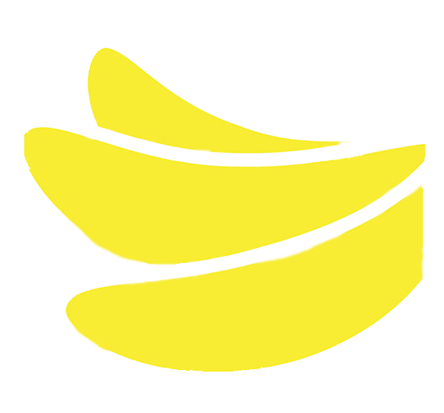  Friday | Breaded Fish Fillet  served with Chips and Garden Peas |  | Oven Baked Jacket Potato  filled with Cheese, Tuna, Beans and Cheese & Beans served with Mixed Salad |  | Assorted Sandwiches  filled with Ham, Cheese or Tuna served with Mixed Salad |  | Jam & Coconut Sponge  or  Fruit Salad & Yoghurt
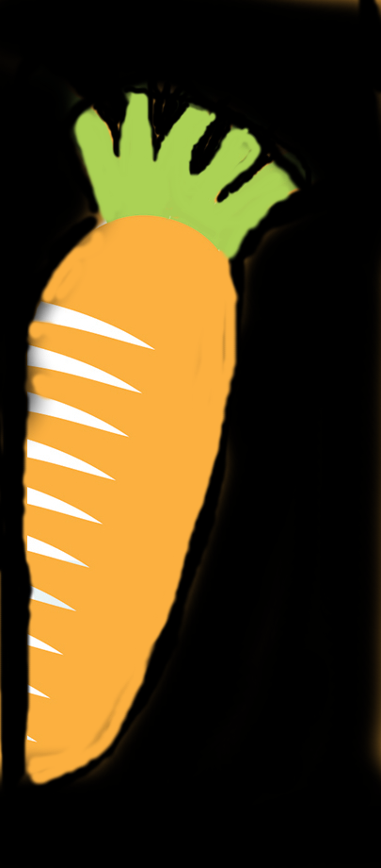
Wednesday
Available Daily: Fresh Fruit and Bread!
If you have any questions about food allergens please speak to the kitchen team who will be happy to help.
ORFORM44 ISSUE 1 – 18.10.18 AUTUMN 2022
Freshly made every day!
selside school
Week 2

Day | Choice 1 |  | Choice 2 | Choice 3 |  | PUDDING
Monday | Cheese & Tomato Pizza  served with Sweetcorn and Mixed Salad |  | Oven Baked Jacket Potato  filled with Cheese, Tuna, Beans and Cheese & Beans served with Mixed Salad |  | Assorted Sandwiches  filled with Ham, Cheese or Tuna served with Mixed Salad |  | Apple Crumble & Custard  or  Fruit Salad & Yoghurt
Tuesday | Chilli Con Carne  served with Rice and Mixed Salad |  | Oven Baked Jacket Potato  filled with Cheese, Tuna, Beans and Cheese & Beans served with Mixed Salad |  | Assorted Sandwiches  filled with Ham, Cheese or Tuna served with Mixed Salad |  | Chocolate Crunch  or  Fruit Salad & Yoghurt
 | Sliced Turkey  served with Creamed Potato, Garden Peas & Carrot Medley and Gravy | Oven Baked Jacket Potato  filled with Cheese, Tuna, Beans and Cheese & Beans served with Mixed Salad |  |  | Assorted Sandwiches  filled with Ham, Cheese or Tuna served with Mixed Salad |  | Fruit Salad and Yogurt  or  Flapjack
Thursday | Meat & Potato Pie  served with Mixed Veg and Gravy |  | Oven Baked Jacket Potato  filled with Cheese, Tuna, Beans and Cheese & Beans served with Mixed Salad |  | Assorted Sandwiches  filled with Ham, Cheese or Tuna served with Mixed Salad |  | Pear & Ginger Cake  or  Fruit Salad & Yoghurt
Friday | Cod & Salmon Fishcake  served with Chips, Garden Peas and Tomato Ketchup |  | Oven Baked Jacket Potato  filled with Cheese, Tuna, Beans and Cheese & Beans served with Mixed Salad |  | Assorted Sandwiches  filled with Ham, Cheese or Tuna served with Mixed Salad |  | Marble Sponge & Chocolate Sauce  or  Fruit Salad & Yoghurt
Wednesday

Available Daily: Fresh Fruit and Bread!
If you have any questions about food allergens please speak to the kitchen team who will be happy to help.
ORFORM44 ISSUE 1 – 18.10.18 AUTUMN 2022
selside school
Week 3
Freshly made every day!

Day | Choice 1 |  | Choice 2 | Choice 3 |  | PUDDING
Monday | Sweet Tomato Pasta  served with Garlic Flatbread, Sweetcorn and Mixed Salad |  | Oven Baked Jacket Potato  filled with Cheese, Tuna, Beans and Cheese & Beans served with Mixed Salad |  | Assorted Sandwiches  filled with Ham, Cheese or Tuna served with Mixed Salad |  | Shortbread  or  Fruit Salad & Yoghurt
Tuesday | Breaded Chicken Goujons  served with Jacket Wedges, Baked Beans and Mixed Salad |  | Oven Baked Jacket Potato  filled with Cheese, Tuna, Beans and Cheese & Beans served with Mixed Salad |  | Assorted Sandwiches  filled with Ham, Cheese or Tuna served with Mixed Salad |  | Orange Jelly & Mandarins  or  Fruit Salad & Yoghurt
 | Toad in the Hole with Gravy  served with Roast Potatoes, Carrot and Green Bean Medley | Oven Baked Jacket Potato  filled with Cheese, Tuna, Beans and Cheese & Beans served with Mixed Salad |  |  | Assorted Sandwiches  filled with Ham, Cheese or Tuna served with Mixed Salad |  | Jammy Bun  or  Fruit Salad & Yoghurt
Thursday | Minced Beef & Dumplings  served with Creamed Potato and Mixed Veg |  | Oven Baked Jacket Potato  filled with Cheese, Tuna, Beans and Cheese & Beans served with Mixed Salad |  | Assorted Sandwiches  filled with Ham, Cheese or Tuna served with Mixed Salad |  | Fruit Salad and Yogurt  or  Paris Sandwich
Friday | Fish Fingers  served with Chips and Garden Peas |  | Oven Baked Jacket Potato  filled with Cheese, Tuna, Beans and Cheese & Beans served with Mixed Salad |  | Assorted Sandwiches  filled with Ham, Cheese or Tuna served with Mixed Salad |  | Syrup Sponge & Custard  or  Fruit Salad & Yoghurt
Wednesday
If you have any questions about food allergens please speak to the kitchen team who will be happy to help.
ORFORM44 ISSUE 1- 18.10.18 AUTUMN 2022

Available Daily: Fresh Fruit and Bread!

