Freshly made every day!
selside school
week 1

Day | Choice 1 | Choice 2 | Choice 3 |  | PUDDING
Monday | Mac and Cheese  served with Garlic Flatbread and Sweetcorn | Oven Baked Jacket Potato  filled with Cheese & Beans, Cheese, Beans or Tuna served with Carrot and Cucumber Sticks |  | Assorted Sandwiches  filled with Cheese, Ham or Tuna served with Carrot and Cucumber Sticks |  | Apple Upside Down Cake  and Custard  or  Fruit Salad & Yoghurt
Tuesday | Mild Chicken Curry  served with Rice, ½ Garlic Naan and Mixed Peppers | Oven Baked Jacket Potato  filled with Cheese & Beans, Cheese, Beans or Tuna served with Mixed Salad |  | Assorted Sandwiches  filled with Cheese, Ham or Tuna served with Mixed Salad |  | Orange Jelly and Mandarins  or  Frozen Yoghurt or Fruit Salad
 | Roast Chicken Fillet  served with Creamed Potatoes, Carrot and Pea Medley and Gravy | Oven Baked Jacket Potato  filled with Cheese & Beans, Cheese, Beans or Tuna served with Mixed Salad |  | Assorted Sandwiches  filled with Cheese, Ham or Tuna served with Mixed Salad |  | Fruity Flapjack  or  Frozen Yoghurt or Fresh Fruit Salad
Thursday | Sausage and Bean Casserole  served with Broccoli and Crusty Bread | Oven Baked Jacket Potato  filled with Cheese & Beans, Cheese, Beans or Tuna served with Carrot and Cucumber Sticks |  | Assorted Sandwiches  filled with Cheese, Ham or Tuna served with Carrot and Cucumber Sticks |  | Vanilla and Raspberry Cookie  or  Fruit Salad & Yoghurt
Friday | Breaded Salmon Goujons  served with Chips and  Garden Peas | Oven Baked Jacket Potato  filled with Cheese & Beans, Cheese, Beans or Tuna served with Carrot and Cucumber Sticks |  | Assorted Sandwiches  filled with Cheese, Ham or Tuna served with Carrot and Cucumber Sticks |  | Marble Cake and Chocolate Sauce  or  Fruit Salad & Yoghurt
Wednesday
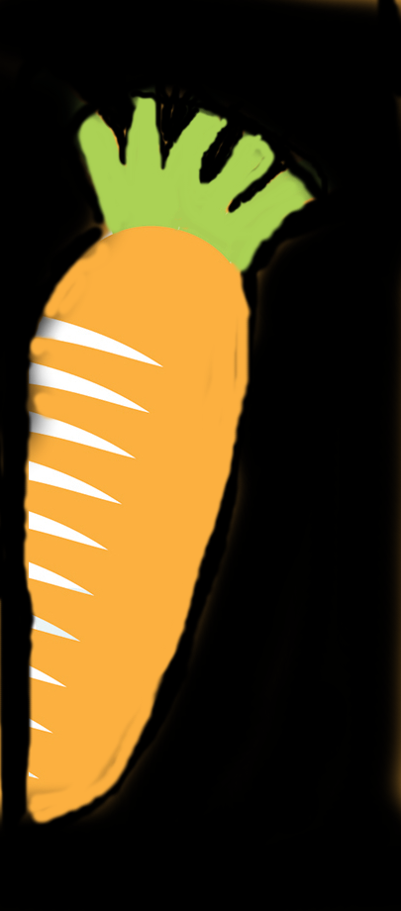
Available Daily: Fresh Fruit and Salad Bar
If you have any questions about food allergens, please speak to the kitchen team who will be happy to help.
ORFORM44 ISSUE 1 – 18.10.18 AUTUMN/WINTER 2023
selside school
Week 2
Freshly made every day!

Day | Choice 1 | Choice 2 | Choice 3 |  | PUDDING
Monday | Margherita Pizza  served with Carrot and Cucumber sticks and Sweetcorn | Oven Baked Jacket Potato  filled with Cheese & Beans, Cheese, Beans or Tuna served with Carrot and Cucumber Sticks |  | Assorted Sandwiches  filled with Cheese, Ham or Tuna served with Carrot and Cucumber Sticks |  | Classic Shortbread  or  Fruit Salad & Yoghurt
Tuesday | Pork Sausages  served with Creamed Potatoes and Baked Beans | Oven Baked Jacket Potato  filled with Cheese & Beans, Cheese, Beans or Tuna served with  Mixed Salad |  | Assorted Sandwiches  filled with Cheese, Ham or Tuna served with Mixed Salad |  | Fresh Fruit Salad  or  Chocolate Crunch or Frozen Yoghurt
 | Roast Beef  served with Yorkshire Pudding, Roast Potatoes, Carrot and Green Bean Medley and Gravy | Oven Baked Jacket Potato  filled with Cheese & Beans, Cheese, Beans or Tuna served with Carrot and Cucumber Sticks |  | Assorted Sandwiches  filled with Cheese, Ham or Tuna served with Carrot and Cucumber Sticks |  | Orange Drizzle Cake  or  Fruit Salad & Yoghurt
Thursday | Meat and Potato Pie  served with Pea & Sweetcorn Medley, Crusty Bread and Gravy | Oven Baked Jacket Potato  filled with Cheese & Beans, Cheese, Beans or Tuna served with  Mixed Salad |  | Assorted Sandwiches  filled with Cheese, Ham or Tuna served with Mixed Salad |  | Fresh Fruit Salad  or  Oaty Cookie or Frozen Yoghurt
Friday | Fish Fingers  served with Chips and Peas | Oven Baked Jacket Potato  filled with Cheese & Beans, Cheese, Beans or Tuna served with Carrot and Cucumber Sticks |  | Assorted Sandwiches  filled with Cheese, Ham or Tuna served with Mixed Salad |  | Golden Syrup Sponge and Custard  or  Frozen Yoghurt or Fruit Salad
Wednesday
Available Daily: Fresh Fruit and Salad Bar
If you have any questions about food allergens, please speak to the kitchen team who will be happy to help.
ORFORM44 ISSUE 1 -18.10.18 AUTUMN/WINTER 2023
selside school
Week 3
Freshly made every day!

Day | Choice 1 | Choice 2 | Choice 3 |  | PUDDING
Monday | Cheesy Pizza  served with Oven Baked Potato Wedges and Mixed Salad | Oven Baked Jacket Potato  filled with Cheese & Beans, Cheese, Beans or Tuna served with  Mixed Salad |  | Assorted Sandwiches  filled with Cheese, Ham or Tuna served with Mixed Salad |  | Custard Cream Cookie  or  Fruit Salad & Yoghurt
Tuesday | Creamy Chicken Pie  served with Baby Potatoes and Carrots | Oven Baked Jacket Potato  filled with Cheese & Beans, Cheese, Beans or Tuna served with  Mixed Salad |  | Assorted Sandwiches  filled with Cheese, Ham or Tuna served with Mixed Salad |  | Chocolate and Beetroot Brownie  or  Frozen Yoghurt or Fresh Fruit Salad
 | Roast Pork and Apple Sauce  served with Roast Potatoes, Cauliflower and Gravy | Oven Baked Jacket Potato  filled with Cheese & Beans, Cheese, Beans or Tuna served with  Mixed Salad |  | Assorted Sandwiches  filled with Cheese, Ham or Tuna served with Mixed Salad |  | Sticky Toffee Pudding  or  Fruit Salad & Yoghurt
Thursday | Homemade Beef Lasagne  served with Mixed Veg and Mixed Pepper Salad | Oven Baked Jacket Potato  filled with Cheese & Beans, Cheese, Beans or Tuna served with  Mixed Salad |  | Assorted Sandwiches  filled with Cheese, Ham or Tuna served with Mixed Salad |  | Fresh Fruit Salad  or  Cherry Shortbread or  Frozen Yoghurt
Friday | Fish Fingers  served with Chips, Garden Peas and Tomato Ketchup | Oven Baked Jacket Potato  filled with Cheese & Beans, Cheese, Beans or Tuna served with  Mixed Salad |  | Assorted Sandwiches  filled with Cheese, Ham or Tuna served with Mixed Salad |  | Jam & Coconut Sponge  or  Fruit Salad & Yoghurt
Wednesday
Available Daily: Fresh Fruit and Salad Bar
If you have any questions about food allergens, please speak to the kitchen team who will be happy to help.
ORFORM44 ISSUE 1 – 18.10.18 AUTUMN/WINTER 2023

