



School uniform policy

Approved by: FGB |  | Date: 28.1.25
Last reviewed on: | 28.1.25
Next review due by: | Jan 2028

Contents
1. Aims 3
2. Our school’s legal duties under the Equality Act 2010 3
3. Limiting the cost of school uniform 3
4. Expectations for school uniform 4
5. Expectations for our school community 5
6. Monitoring arrangements 6
7. Links to other policies 6

1. Aims
This policy aims to:
- Set out our approach to requiring a uniform that is of reasonable cost and offers the best value for money for parents and carers
- Explain how we will avoid discrimination in line with our legal duties under the Equality Act 2010
- Clarify our expectations for school uniform

2. Our school’s legal duties under the Equality Act 2010
The Equality Act 2010 prohibits discrimination against an individual based on the protected characteristics, which include age, sex, disability, race, religion or belief, pregnancy and maternity, and gender reassignment.
To avoid discrimination, our school will:
- Avoid listing uniform items based on sex, to give all pupils the opportunity to wear the uniform they feel most comfortable in or that most reflects their self-identified gender
- Make sure that our uniform costs the same for all pupils
- Allow all pupils to have long hair (though we reserve the right to ask for this to be tied back)
- Allow all pupils to style their hair in a way that is appropriate for school and makes them feel most comfortable
- Allow pupils to request changes to swimwear for religious reasons or if they are experiencing discomfort related to their sex, gender or gender reassignment
- Allow pupils to wear headscarves and/or other religious garments
- Allow pupils with sensory or physical needs to make reasonable adaptations to their uniform depending on their specific needs
- Allow for reasonable adaptations to our policy on the grounds of equality by asking pupils or their parents/carers to get in touch with Headteacher who can answer questions about the policy and respond to any requests. These will be considered on a case-by-case basis.

3. Limiting the cost of school uniform
Our school has a duty to make sure that the uniform we require is affordable, in line with statutory guidance from the Department for Education (DfE) on the cost of school uniform.
We understand that items with distinctive characteristics (such as branded items, or items that need to have a school logo or a unique fabric/colour/design) cannot be purchased from a wide range of retailers and that requiring many such items limits parents/carers’ ability to ‘shop around’ for a low price.
We will make sure our uniform:
- Is available at a reasonable cost
- Provides the best value for money for parents/carers
We will do this by:
- Carefully considering whether any items with distinctive characteristics are necessary
- Limiting any items with distinctive characteristics where possible
- Limiting items with distinctive characteristics to low-cost and/or long-lasting items, such as ties
- Considering cheaper alternatives to school-branded items, such as logos that can be ironed on, as long as this doesn’t compromise quality and durability
- Avoiding specific requirements for items pupils could wear on non-school days, such as coats, bags and shoes
- Keeping the number of optional branded items to a minimum, so that the school’s uniform can act as a social leveler
- Avoiding different uniform requirements for different year/class/house groups
- Avoiding different uniform requirements for extra-curricular activities
- Considering alternative methods for signaling differences in groups for interschool competitions, such as creating posters or labels
- Making sure that arrangements are in place for parents/carers to acquire second-hand uniform items
- Avoiding frequent changes to uniform specifications and minimising the financial impact on parents/carers of any changes
- Consulting with parents/carers and pupils on any proposed significant changes to the uniform policy and carefully considering any complaints about the policy

4. Expectations for school uniform
4.1 Our school’s uniform
Selside School has a policy that all children should wear the school uniform; this helps to create a sense of community and identifies everyone as belonging to Selside School. We have a simple school uniform, which is required to be worn each school day. Branded items aren’t required. Local supermarket retailers do stock royal blue jumpers/cardigans also.

Winter Uniform | Summer Uniform*
Royal jumper/cardigan embroidered logo available | Royal jumper/cardigan embroidered logo available
White polo/shirt/blouse embroidered logo available | White polo/shirt/blouse embroidered logo available
Black or grey trousers with plain black or grey socks  or  Black or grey skirt/tunic with black or grey tights to match | Black or grey trousers/shorts  with plain black or grey socks  or  Black or grey skirt/shorts with plain white knee or ankle socks
 | Blue and white checked summer dresses with plain white knee or ankle socks
 | Sun hat/cap embroidered logo available
Black school shoes, boots or plain black trainers (no logos or colour) | Black school shoes, boots or plain black trainers (no logos or colour)

Winter PE Kit  PE Kit is not required for Nursery children  To be worn on your PE day | Summer PE Kit  PE Kit is not required for Nursery children  To be worn on your PE day
Royal Blue/navy hoodie embroidered logo available | Royal Blue/navy hoodie embroidered logo available
Plain White T-shirt | Plain White T-shirt
Navy blue or black jogging/tracksuit bottoms or leggings for outdoors | Navy blue or black PE Shorts
Trainers | Trainers


4.2 Where to purchase it
Our Sweatshirts, white T-shirts and polo shirts with the school logo can be ordered directly from One Identity, 64-68 Cavendish Street, Barrow-in-Furness, Cumbria, LA14 1PZ. Tel: 01229 823584 or via their website. Upon ordering you will be able to select to home or school delivery (please note school delivery is free).
Our link to the One Identity Website is https://www.oneidentity.co.uk/selside/
The link requires a password – please contact the school office for this.

Swap Shop
The school runs a swap shop for pre-loved uniform once a term. This is an opportunity for families to bring in any uniform which are no longer needs and to pick up second-hand item; for enquires during term time ask at the school office.

5. Expectations for our school community
5.1 Pupils
Pupils are expected to wear the correct uniform at all times (other than specified non-school uniform days) while:
- On the school premises
- Travelling to and from school
- At out-of-school events or on trips that are organised by the school, or where they are representing the school (if required)
- No jewellery is allowed except a wrist watch and small stud earrings.
Pupils are also expected to contact headteacher if they want to request an amendment to the uniform policy in relation to their protected characteristics.
5.2 Parents and carers
Parents and carers are expected to make sure their child has the correct uniform and PE kit, and that every item is:
- Clean
- Clearly labelled with the child’s name
- In good condition
Parents/carers are also expected to contact headteacher if they want to request an amendment to the uniform policy in relation to:
- Their child’s protected characteristics
- The cost of the uniform
Parents/carers are expected to lodge any complaints or objections relating to the school uniform in a timely and reasonable manner.
Disputes about the cost of the school uniform will be:
- Resolved locally
- Dealt with in accordance with our school’s complaints policy
The school will work closely with parents/carers to arrive at a mutually acceptable outcome.
5.3 Staff
Staff will closely monitor pupils to make sure they are in correct uniform. They will give any pupils and families breaching the uniform policy the opportunity to comply, but will follow up with the headteacher if the situation doesn’t improve.
Ongoing breaches of our uniform policy will be dealt with by class teacher and then Headteacher.
In cases where it is suspected that financial hardship has resulted in a pupil not complying with this uniform policy, staff will take a mindful and considerate approach to resolving the situation.
5.4 Governors
The governing board will review this policy and make sure that it:
- Is appropriate for our school’s context
- Is implemented fairly across the school
- Takes into account the views of parents/carers and pupils
- Offers a uniform that is appropriate, practical and safe for all pupils
The board will also make sure that the school’s uniform supplier arrangements give the highest priority to cost and value for money, for example by avoiding single supplier contracts and by re-tendering contracts at least every 5 years.

6. Monitoring arrangements
This policy will be reviewed every 3 years or when required by the Headteacher. At every review, it will be approved by the full governing board.

Appendix 1 – Selside School Uniform

Winter uniform
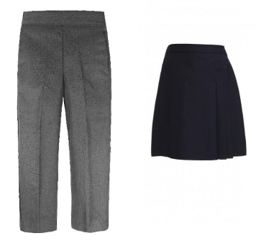
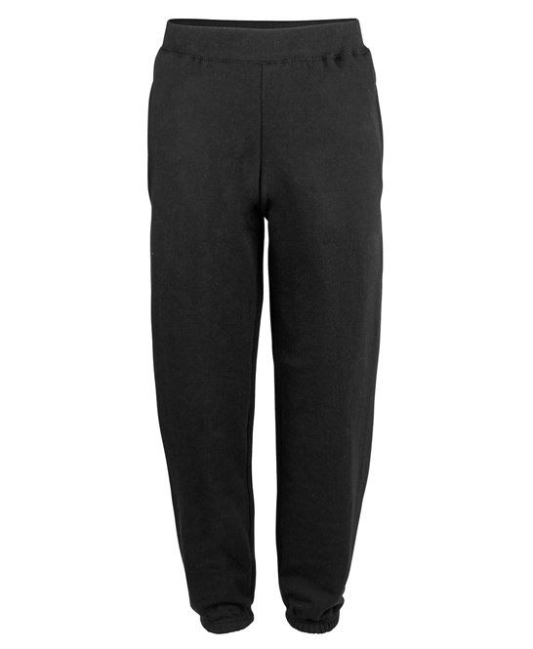
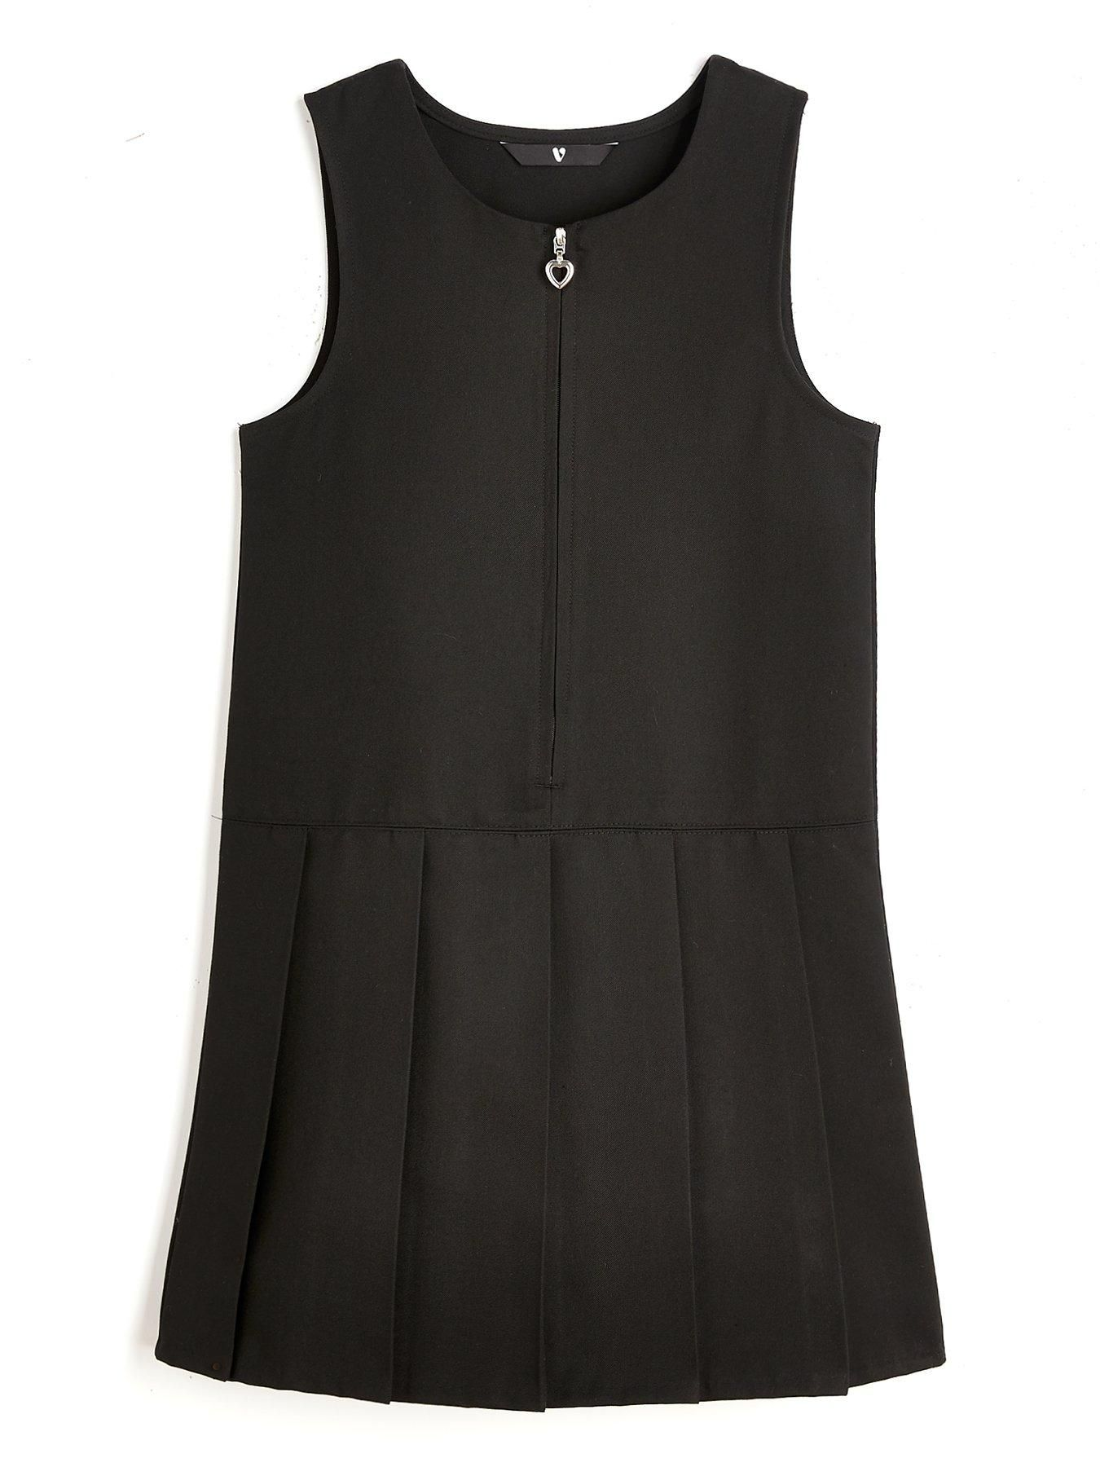

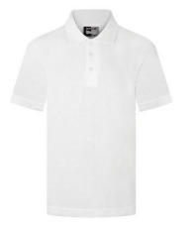
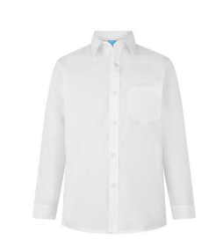

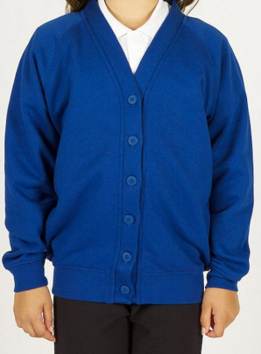
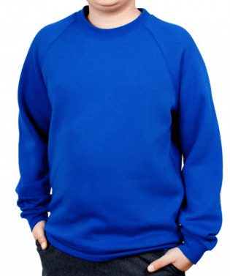


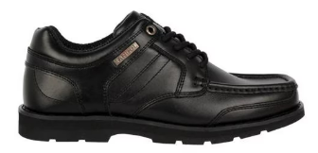
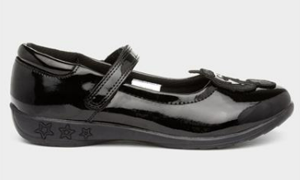
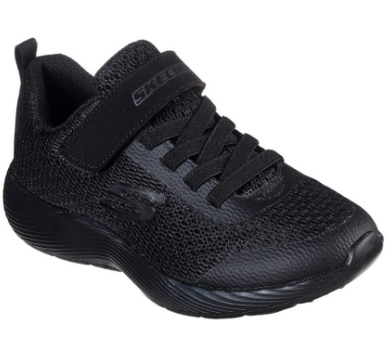
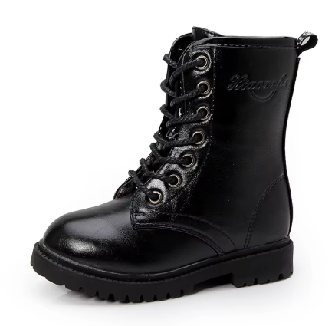

Optional summer Uniform
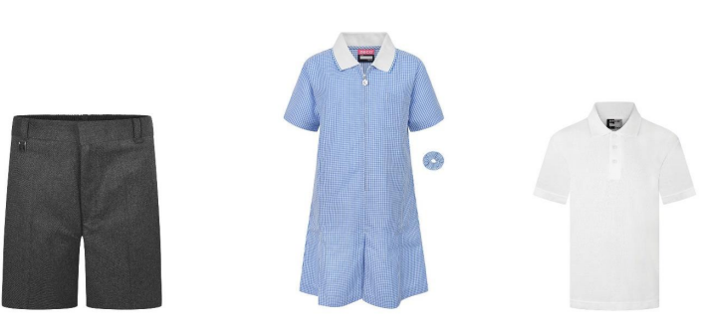

PE uniform
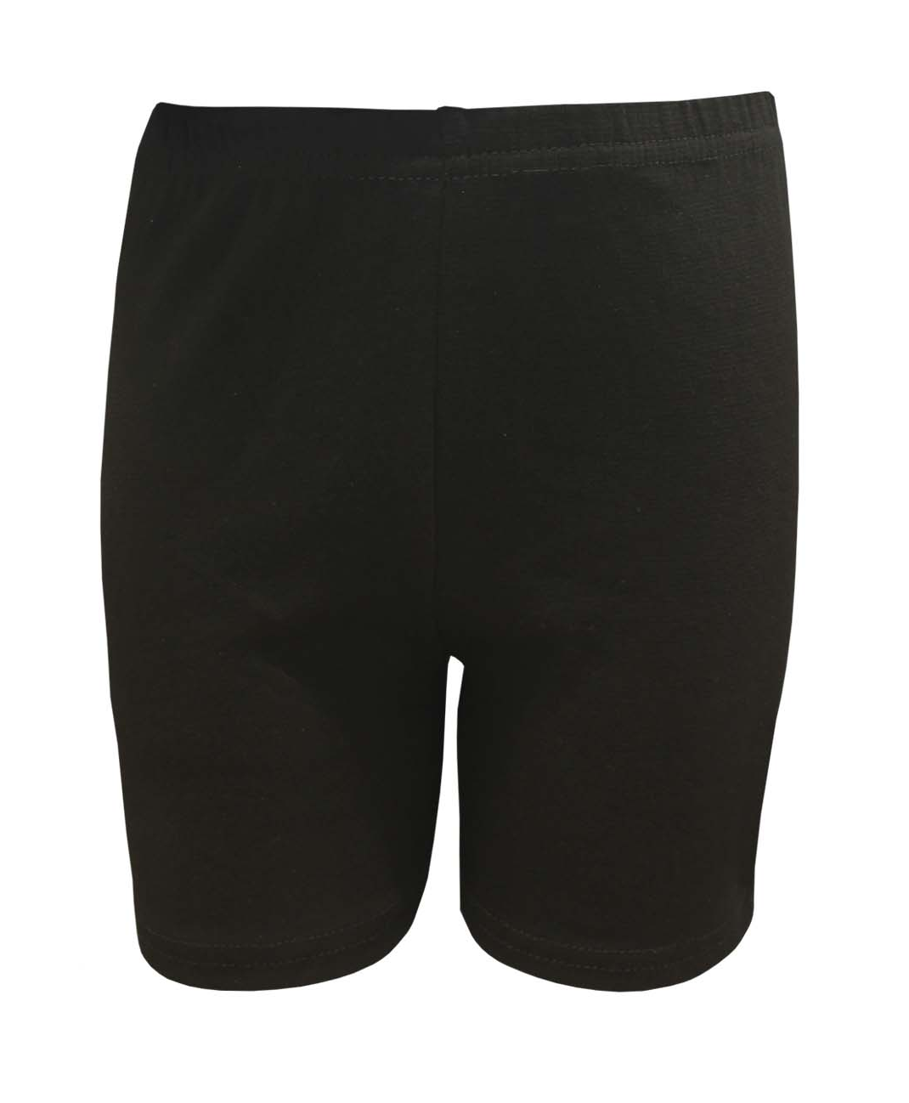
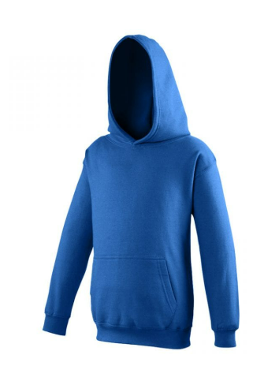
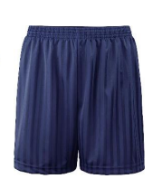
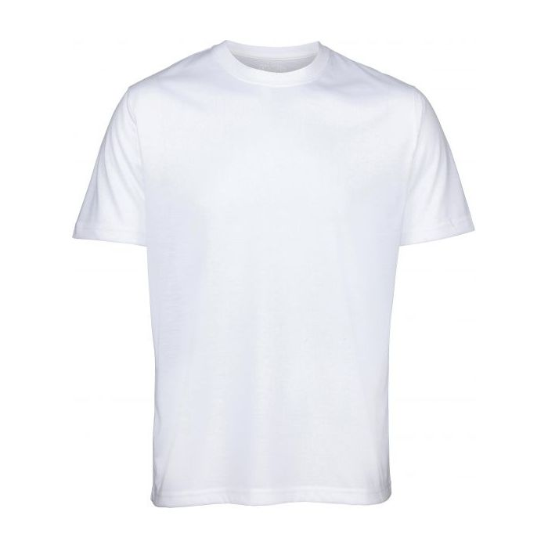

Operational Extra winter items

